{!Job Title}
{!Location} // {!FullvPartTime} // {!Department} // {!ExperienceLevel}

{!Company} helps {!who you help}. We {!help/build...}. We are looking for a {!quality 1}, {!quality 2}, {!quality 3}, {!role} who is excited to help {!do what} for our {!department hiring} team.

We are looking for someone who…
- Is an experienced {!role}
- Has successfully {!action}
- Has worked in a {!environment}
- Is passionate about helping {!customer type}
- Is great at {!skill}
- Is willing to {!necessary action}
- {!Is/Has…}
- {!Is/Has…}

Duties and Responsibilities
- {!IndustryExperience}
- {!ProgramExperience}
- Experience in {!tasks}
- {!Qualities}
- {!Habits}
- {!Attitude}
- {!CommunicationSkills}
- {!OtherTraits}

Nice to Haves
- {!AdditionalExperience1}
- {!AdditionalExperience2}
- {!Desires}
- {!Passions}

About the Company
{!Our company} is a team of {!Adj1}, {!Adj2}, {!Adj3} people working together to {!mission}. We {!Action1}, {!Action2}, {!Action3} a {!Product/Service} that {!Value}.

You can find us {!Location}. We offer {!HighLevelBenefit}. We also offer a growing list of benefits: {!Benefit1}, {!Benefit2}, {!Benefit3}, {!Benefit4}, {!Benefit5}, as well as {!Benefit6}. Additional perks include {!Perks}.

{!Our company} is proud to be {!VentureBackingsOrHistoryFunFact}. Our customers range from {!This} to {!That}, like {!Customer1}, {!Customer2}, {!Customer3}, and many more. We live out our core values every day in a mission to {!Mission}.

-------------------------------------------------------------------------------------------------------------------------------

Directions to save this template with easy-to-fill fields:

Ready to get your template looking like this?

- Download Yesware to your Gmail or Outlook inbox (free).
- Click the Templates module

Here’s what it looks like in Gmail:
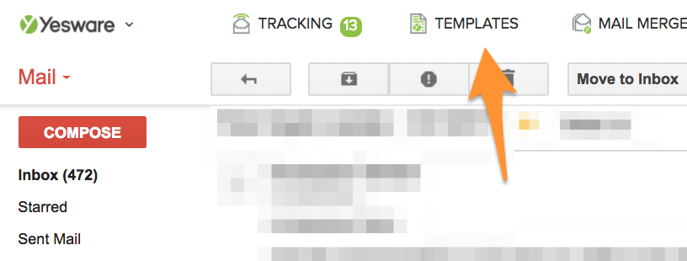

And here’s what it looks like in Outlook:
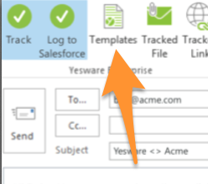

- Click the blue “New Template” button.
- Give the template a name (ignore the Email Subject for now).
- Copy the job description template above, and paste it here:
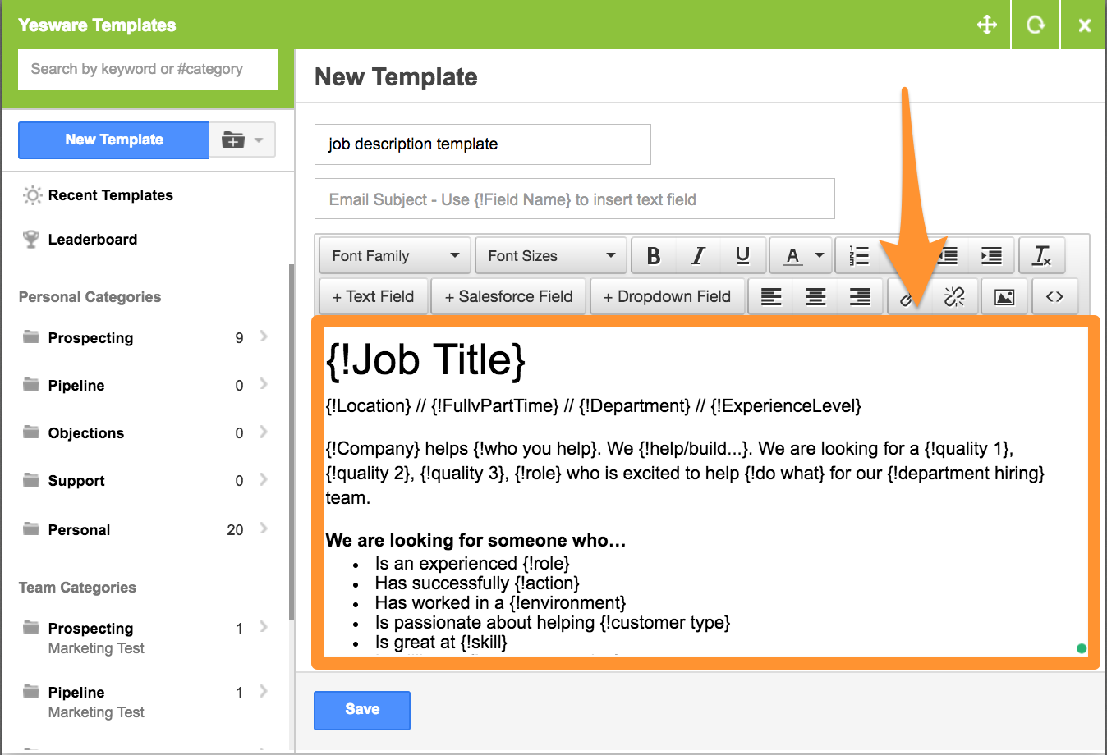
- Click the blue Save button to turn the “{!xxx} fields into fillable placeholders.

Any time you want to use the template for a new job description, just click on the Templates button in your inbox, search for the name, and there it is!

What else can your Yesware trial do for you?

1. Email Tracking: Know when candidates are opening your emails
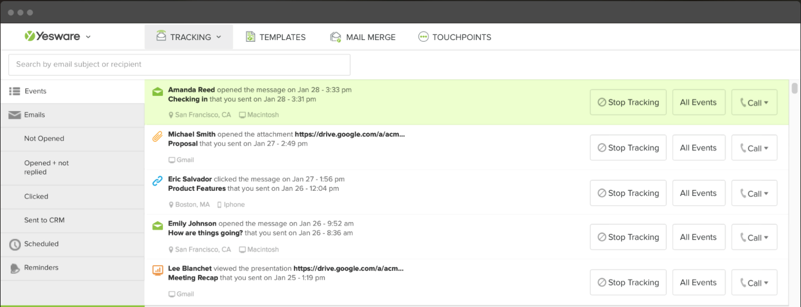

2. Book A Time: Books phone screens faster by pulling your calendar into your email

3. Mail Merge: Automate email campaigns (with open- or reply-based follow-up) to up to 200 candidates at once
Click here to get your free trial.

